SPRING 2024
COURSE CODE: CSE421
COURSE TITLE: Computer Networks

LAB - 02(Wireshark)

PREPARED BY
Name: Nur-E-Jannat
ID: 21301744
Section: 14
Email: nur.e.jannat@g.bracu.ac.bd



- Checking IP address of client and server:
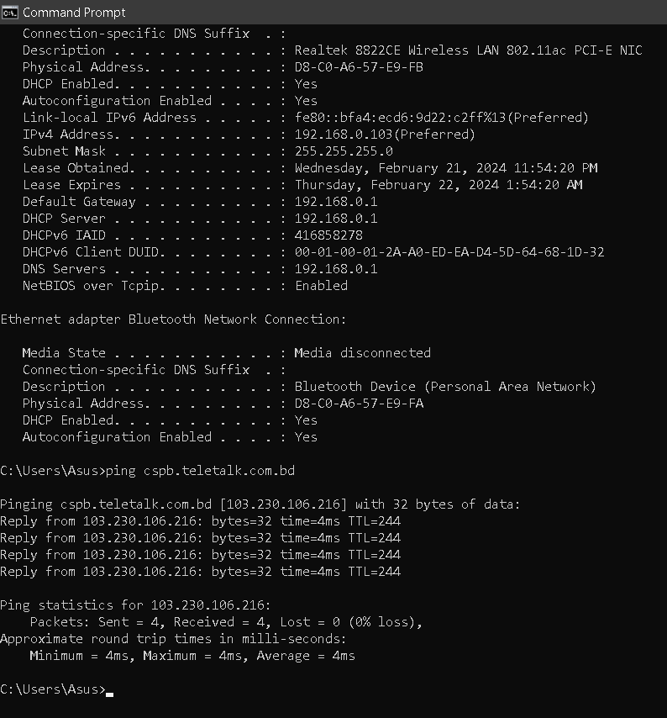

- 5 layer protocols headers for a request packet:
- Frame header contains the data link layer information, including the MAC addresses of both the sender and the recipient. The source MAC address identifies the network interface of the sender, while the destination MAC address specifies the intended recipient's network interface. Source MAC Address identifies the MAC address of the sender's network interface and destination MAC Address specifies the MAC address of the recipient's network interface.
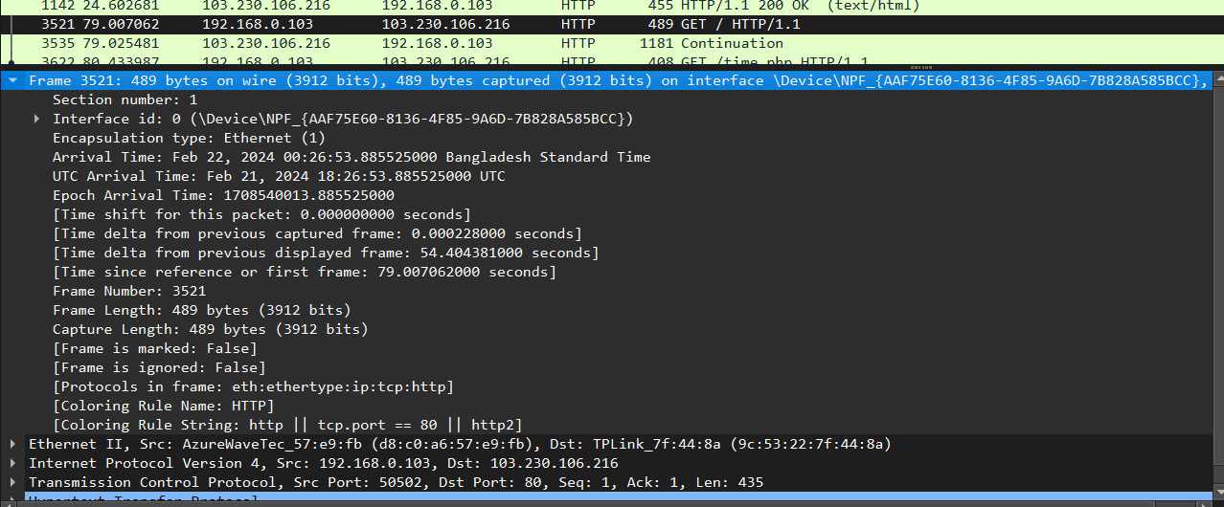

b. The Ethernet header indicates the protocol used in the payload, such as IPv4 or IPv6.This header facilitates the proper demultiplexing of incoming frames at the receiving end.
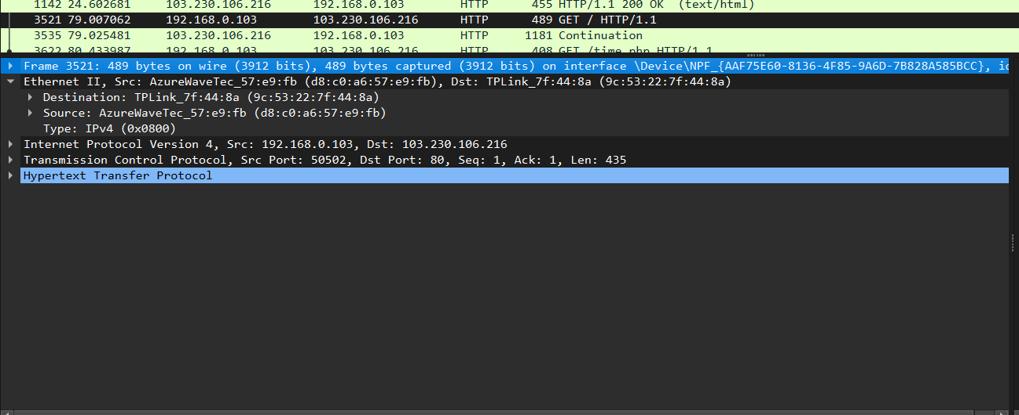

c. At the network layer, the IP header contains critical information for routing and delivering packets across networks. It includes the source and destination IP addresses, which are essential for identifying the sender and recipient of the packet. The IP address of the sender is 192.168.0.103 and the IP address of the recipient is 103.230.106.216

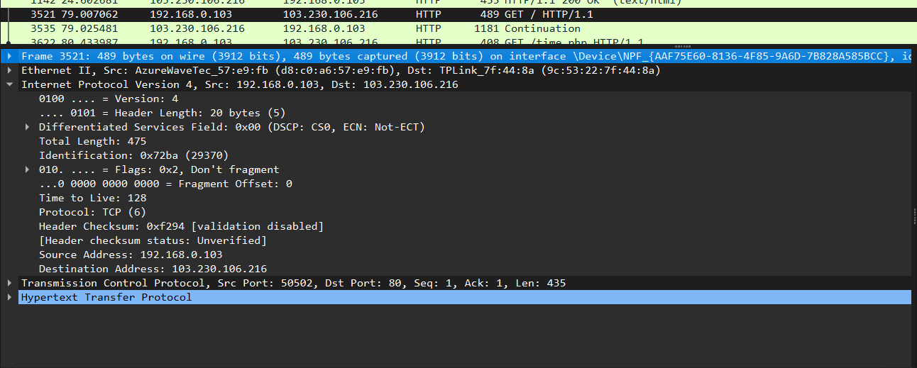

d. The port number of the sender's application or service(Source Port) and the port number of the recipient's application or service(Destination port). This typically includes the source and destination port numbers, which help identify the specific application or service on each host that should receive the data. Additionally, the transmission header may include fields such as sequence numbers, acknowledgment numbers, window size, checksum, and various flags (SYN, ACK) for managing the flow and reliability of data transmission.

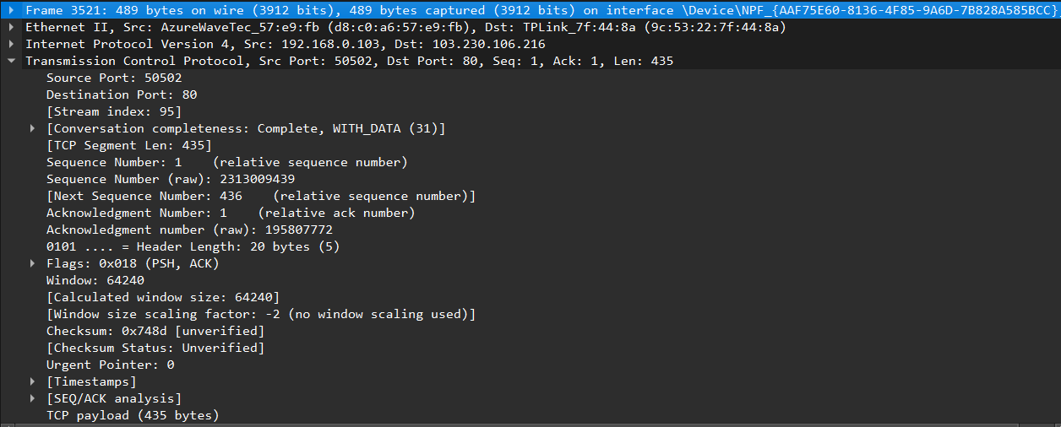

e. Status Code indicates the HTTP status code, conveying the outcome of the request (200-OK, 404-Not Found). Content-Type specifies the type of content returned in the response (text/html). The HTTP header carries metadata about the HTTP request, providing instructions and information to the client about the content being transferred.

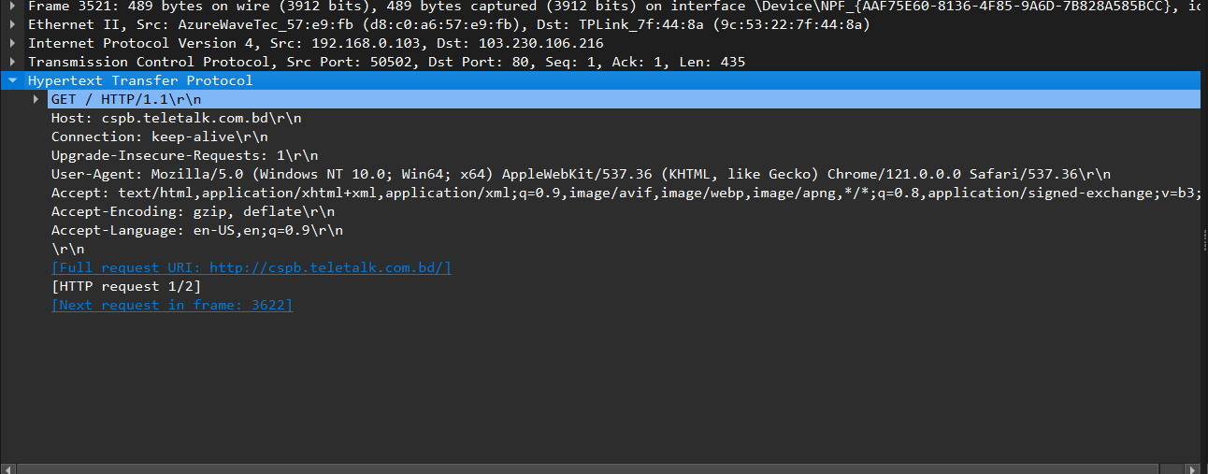

- 5 layer protocols headers for a response packet:
a. Source MAC Address is the MAC address of the server's network interface and destination MAC Address is The MAC address of the sender's network interface.

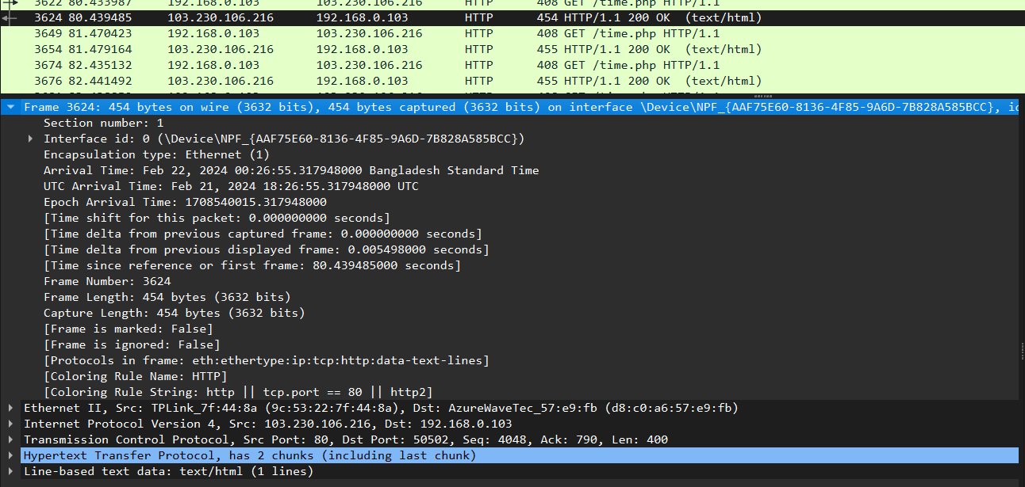

b. Ethernet Header indicates the protocol used in the payload, such as IPv4 or IPv6.

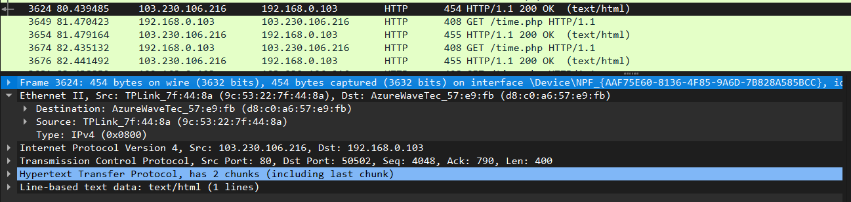

c. Source IP Address is the IP address of the server (103.230.106.216) and
destination IP Address is the IP address of the sender (192.168.0.103).

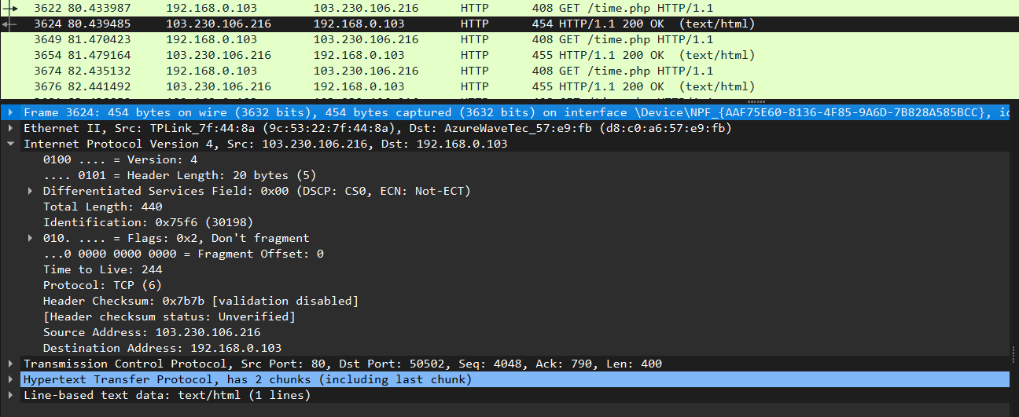

d. Source Port Number is the port number used by the server's application and destination Port Number is the port number used by the client's application.

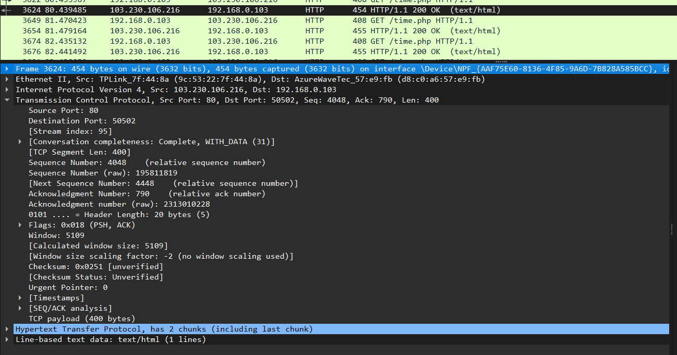

e. The HTTP header carries metadata about the HTTP response, providing instructions and information to the server about the content being transferred.
